1. Student from class A :

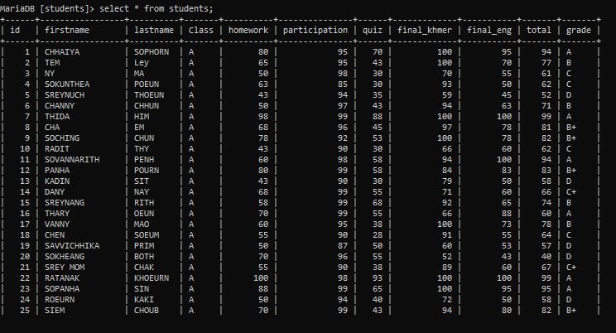

1. Student failed quiz in class C :

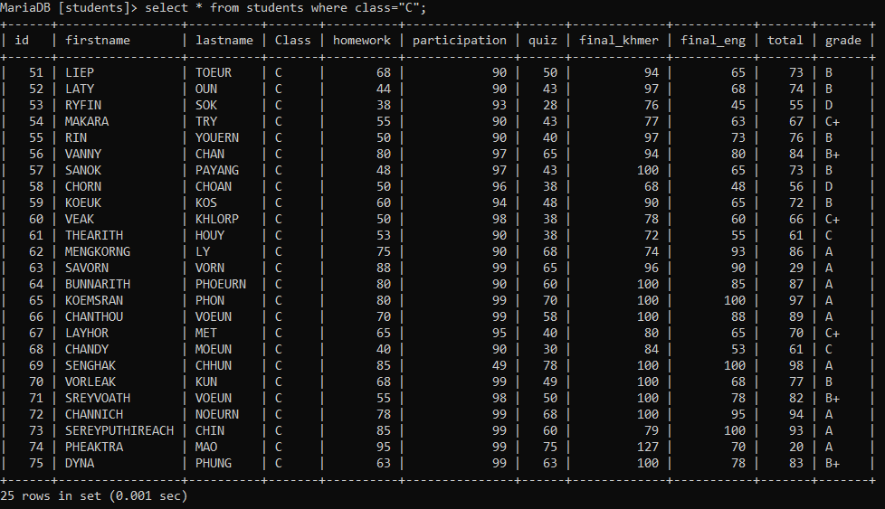

1. Students need to do make up exam all class :

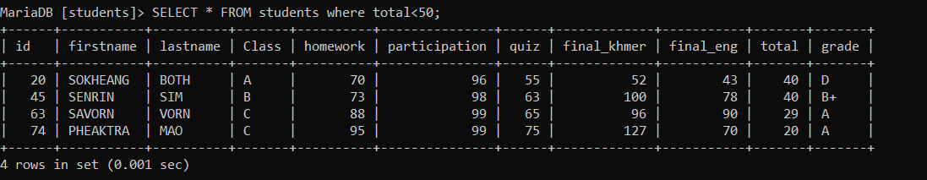

1. Students get score between 80-100

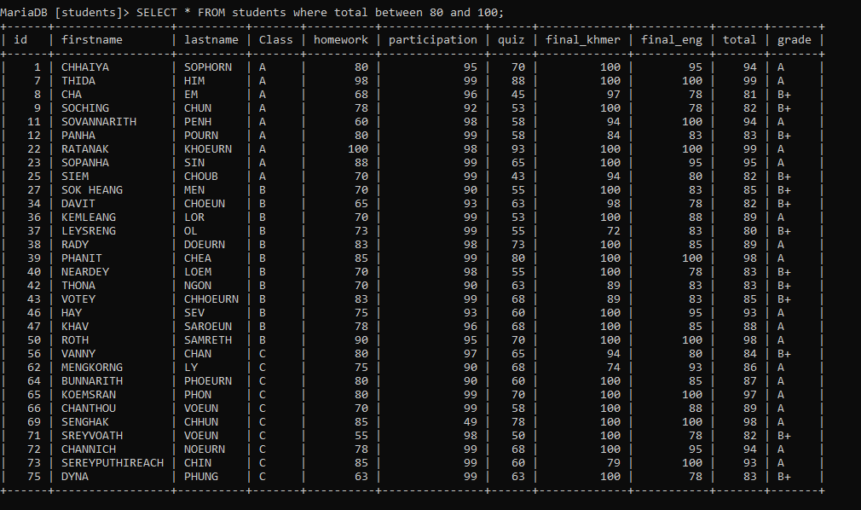

1. Students have lastname finished with letter “N”

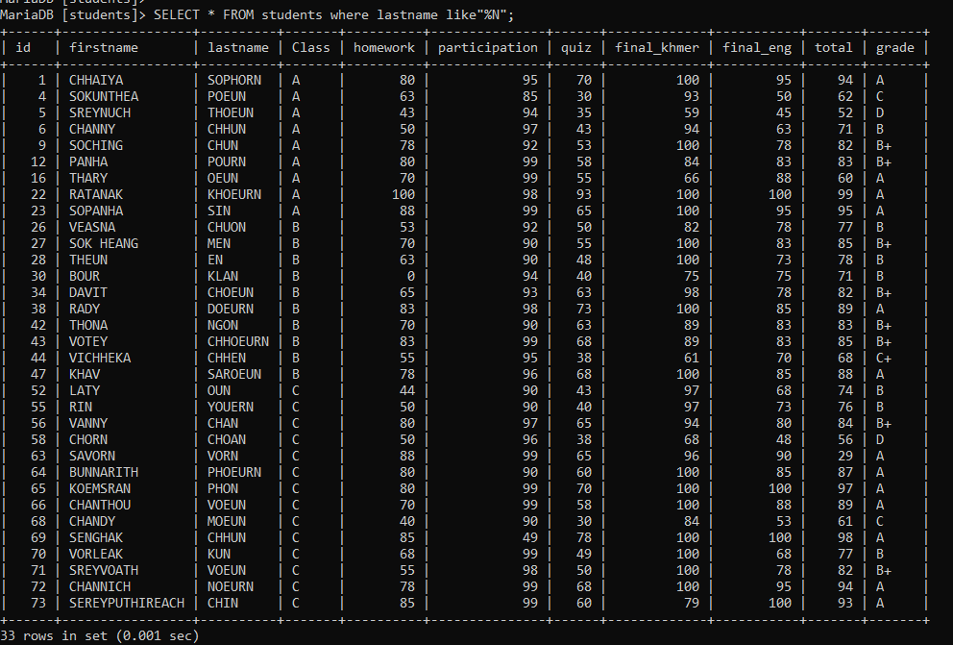

1. Students have firstname start with letter “S”

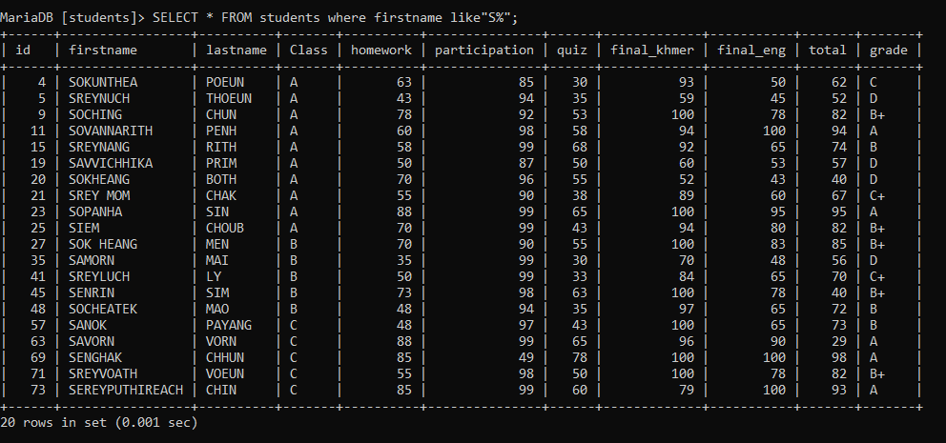

1. Only students has grade A from class B display only firstname and lastname and grade

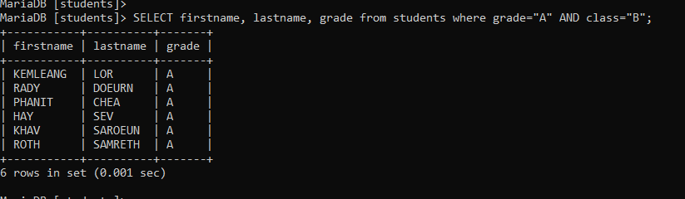

1. Sum all score for vorleak

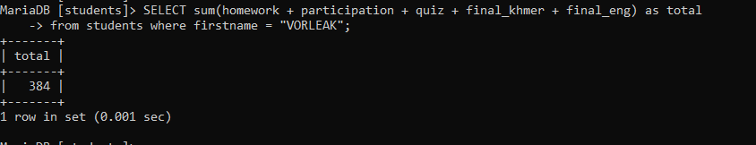

1. Update Pheaktra and Sanok from class C to class B

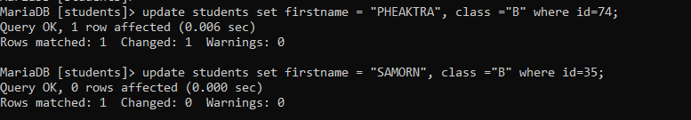

1. students get grade A are

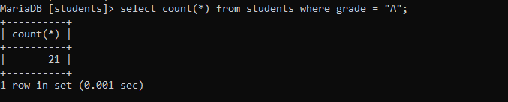

1. Delete all students who failed quiz

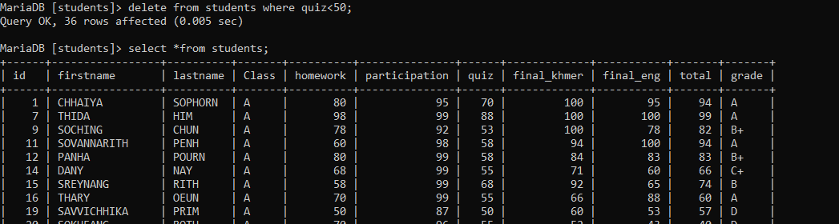

1. merge firstname and lastname to one column

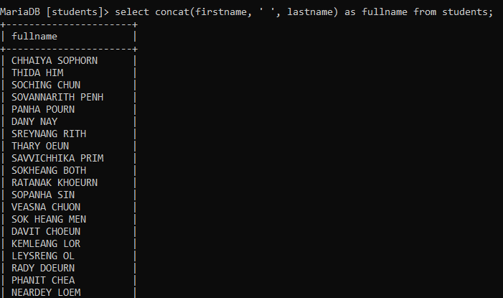

1. Get first 10 students from the list

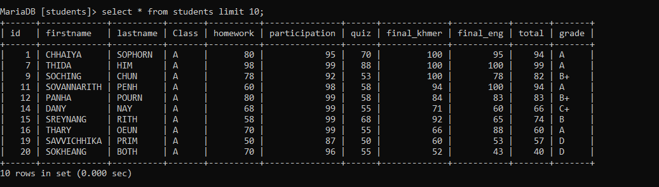

1. Get Average total score from the list

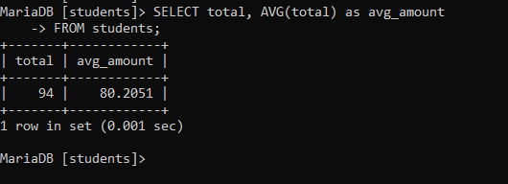

1. Get all who have total score less than average score of the list

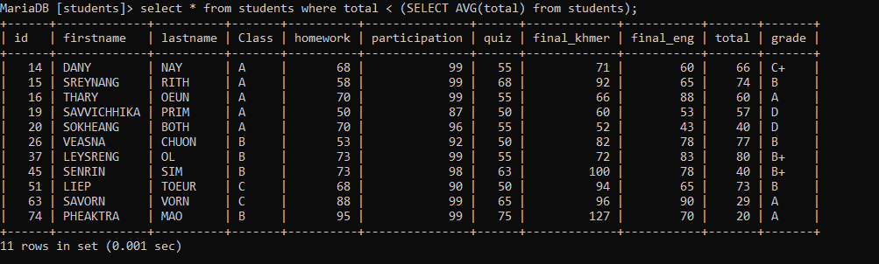

1. Get all who have total score equal maximum score in the list

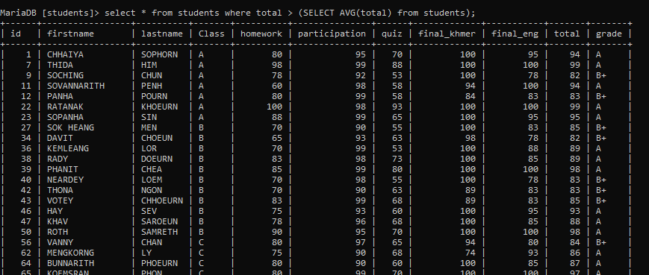

1. Get all who have quiz score equal minimum score quiz in the list

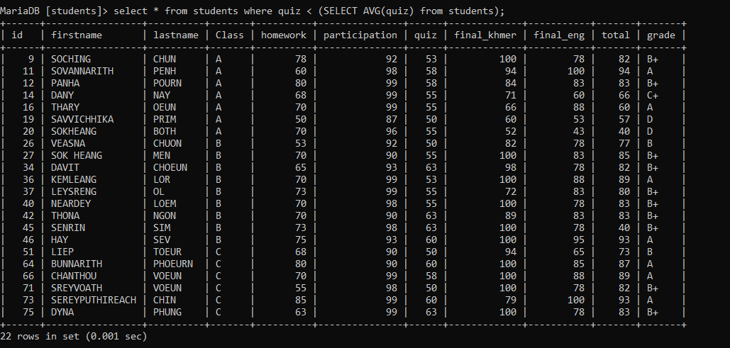

1. Get all students who have maximum score equal total and quiz score less than average quiz score

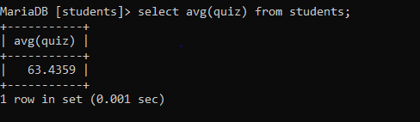

1. Get all students order by lastname desc

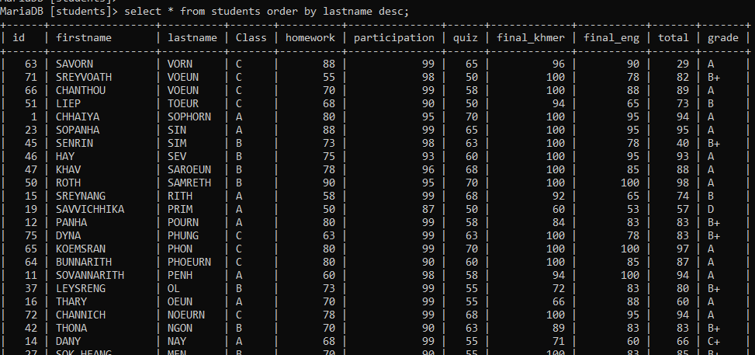

1. Get unique grade from table

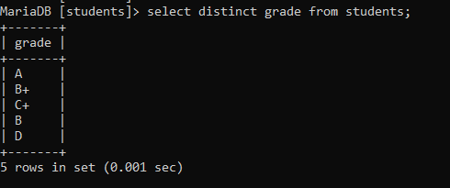

1. Get firstname, lastname of students and group by class

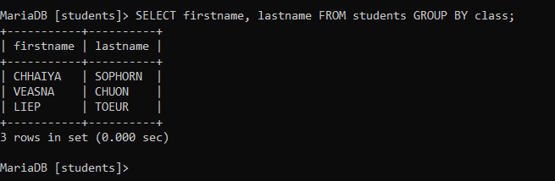

1. Get full name, homework, quiz, total

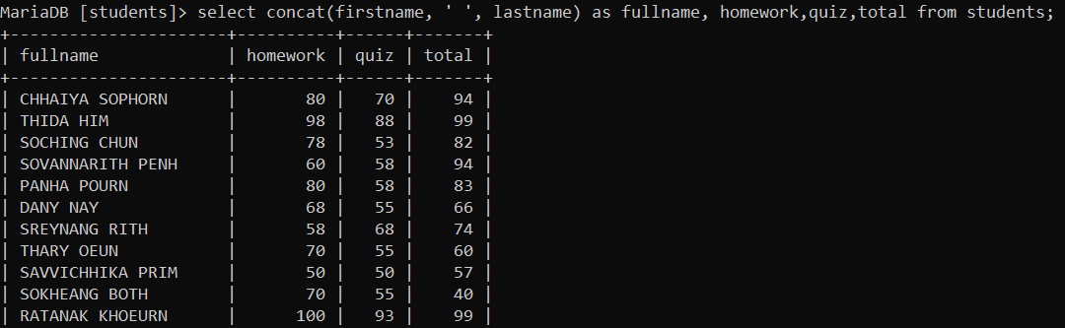

1. Delete who has firstname start with letter “C”

